**Databases Laboratory Work Nr 6**

**Title:** Tables and indices creation

**Prerequisites:** SQL Server 2019 and SSMS

**Objectives:** Get practical experience in creation of tables and indices.

**Student:** Novitchi Nichita

**Implementation**

USE universitatea;

/* Task 1 */

BEGIN

UPDATE profesori

SET Adresa_Postala_Profesor = 'mun. Chisinau'

WHERE Adresa_Postala_Profesor IS NULL

SELECT * FROM profesori

END

/* Task 2 */

BEGIN

ALTER TABLE grupe

ALTER COLUMN Cod_Grupa VARCHAR(255) NOT NULL

ALTER TABLE grupe

ADD CONSTRAINT UQ_Cod_Grupa UNIQUE (Cod_Grupa)

ALTER TABLE grupe

ADD CONSTRAINT PK_grupe PRIMARY KEY (Id_Grupa)

SELECT * FROM grupe

END

/* Task 3 */

BEGIN

ALTER TABLE grupe

ADD Sef_grupa INT

ALTER TABLE grupe

ADD CONSTRAINT UQ_Sef_Grupa UNIQUE (Sef_Grupa)

ALTER TABLE grupe

ADD Prof_Indrumator INT

UPDATE grupe

SET Sef_grupa = (SELECT TOP(1) Id_Student, Id_Grupa FROM studenti_reusita

WHERE studenti_reusita.Id_Grupa = grupe.Id_Grupa

GROUP BY Id_Student

ORDER BY SUM(Nota) DESC)

UPDATE grupe

SET Prof_Indrumator = (SELECT TOP(1) Id_Profesor FROM (SELECT TOP(1000) Id_Profesor FROM studenti_reusita

WHERE studenti_reusita.Id_Grupa = grupe.Id_Grupa

GROUP BY Id_Profesor, Id_Grupa

ORDER BY COUNT(DISTINCT Id_Disciplina) DESC, Id_Profesor DESC) AS temp)

SELECT * FROM grupe

END

/* Task 4 */

BEGIN

UPDATE studenti_reusita

SET Nota = Nota + 1

WHERE Nota < 10 AND Id_Student IN (SELECT Sef_grupa FROM grupe)

END

/* Task 5 */

GO

CREATE FUNCTION dbo.GetEnd (@STRING AS VARCHAR(255), @SEGMENT AS INT)

RETURNS INT

BEGIN

DECLARE @END INT

IF @SEGMENT = 1

BEGIN

IF (CHARINDEX(', ', @STRING) != 0)

SET @END = CHARINDEX(', ', @STRING)

ELSE

SET @END = LEN(@STRING) + 1

END

ELSE IF @SEGMENT = 2

BEGIN

IF (CHARINDEX(', ', @STRING) != 0)

SET @END = CHARINDEX(', ', @STRING, CHARINDEX(', ', @STRING) + 2) - CHARINDEX(', ', @STRING) - 2

ELSE

SET @END = 0

END

ELSE IF @SEGMENT = 3

BEGIN

IF (CHARINDEX(', ', @STRING) != 0)

SET @END = LEN(@STRING) - CHARINDEX(', ', @STRING, CHARINDEX(', ', @STRING) + 2) - 1

ELSE

SET @END = 0

END

RETURN @END;

END

GO

CREATE FUNCTION dbo.GetStart (@STRING AS VARCHAR(255), @SEGMENT AS INT)

RETURNS INT

BEGIN

DECLARE @START INT

IF @SEGMENT = 1

SET @START = 0

ELSE IF @SEGMENT = 2

BEGIN

IF (CHARINDEX(', ', @STRING) != 0)

SET @START = CHARINDEX(', ', @STRING) + 2

ELSE

SET @START = 0

END

ELSE IF @SEGMENT = 3

BEGIN

IF (CHARINDEX(', ', @STRING) != 0)

SET @START = CHARINDEX(', ', @STRING, CHARINDEX(', ', @STRING) + 1) + 2

ELSE

SET @START = 0

END

RETURN @START;

END

GO

-- delete function

DROP FUNCTION dbo.GetEnd;

DROP FUNCTION dbo.GetStart;

GO

BEGIN

CREATE TABLE profesori_new (

Id_Profesor INT,

Nume_Profesor VARCHAR,

Prenume_Profesor VARCHAR,

Localitate VARCHAR DEFAULT('Mun. Chisinau'),

Adresa_1 VARCHAR,

Adresa_2 VARCHAR,

)

CREATE CLUSTERED INDEX profesori_new_PK_index

ON profesori_new(Id_Profesor)

SELECT

Id_Profesor,

Nume_Profesor,

Prenume_Profesor,

SUBSTRING(Adresa_Postala_Profesor, dbo.GetStart(Adresa_Postala_Profesor, 1), dbo.GetEnd(Adresa_Postala_Profesor, 1)) as Localitate,

SUBSTRING(Adresa_Postala_Profesor, dbo.GetStart(Adresa_Postala_Profesor, 2), dbo.GetEnd(Adresa_Postala_Profesor, 2)) as Adresa_1,

SUBSTRING(Adresa_Postala_Profesor, dbo.GetStart(Adresa_Postala_Profesor, 3), dbo.GetEnd(Adresa_Postala_Profesor, 3)) as Adresa_2

INTO profesori_new

FROM profesori

select * from profesori_new

END

/* Task 6 */

GO

DROP TABLE IF EXISTS orarul;

CREATE TABLE orarul (

Id_Disciplina INT,

Id_Profesor INT,

Id_Grupa INT,

Zi VARCHAR(10),

Ora TIME,

Auditoriu INT,

Bloc VARCHAR)

GO

INSERT INTO orarul VALUES

(107, 101, 1, 'Luni', '08:00', 202, 'B'),

(108, 101, 1, 'Luni', '11:30', 501, 'B'),

(119, 117, 1, 'Luni', '13:00', 501, 'B')

SELECT * FROM orarul

GO

/* Task 7 */

INSERT INTO orarul

SELECT Id_Disciplina,

(SELECT Id_Profesor FROM profesori WHERE Nume_Profesor = 'Bivol' AND Prenume_Profesor = 'Ion') AS Id_Profesor,

(SELECT TOP(1) Id_Grupa FROM grupe WHERE Cod_Grupa = 'INF171') AS Id_Grupa,

'Luni' as Zi, '08:00' as Ora, 202 as Auditoriu, 'B' as Bloc

FROM discipline WHERE Disciplina = 'Structuri de date si algoritmi';

INSERT INTO orarul

SELECT Id_Disciplina,

(SELECT Id_Profesor FROM profesori WHERE Nume_Profesor = 'Mircea' AND Prenume_Profesor = 'Sorin') AS Id_Profesor,

(SELECT TOP(1) Id_Grupa FROM grupe WHERE Cod_Grupa = 'INF171') AS Id_Grupa,

'Luni' as Zi, '11:30' as Ora, 202 as Auditoriu, 'B' as Bloc

FROM discipline WHERE Disciplina = 'Programe aplicative';

INSERT INTO orarul

SELECT Id_Disciplina,

(SELECT Id_Profesor FROM profesori WHERE Nume_Profesor = 'Micu' AND Prenume_Profesor = 'Elena') AS Id_Profesor,

(SELECT TOP(1) Id_Grupa FROM grupe WHERE Cod_Grupa = 'INF171') AS Id_Grupa,

'Luni' as Zi, '13:00' as Ora, 202 as Auditoriu, 'B' as Bloc

FROM discipline WHERE Disciplina = 'Baze de date';

SELECT * FROM orarul

GO

/* Task 8 */

CREATE NONCLUSTERED COLUMNSTORE INDEX non_clust_discpline

ON studenti(Id_Student, Nume_Student, Prenume_Student)

WITH (DATA_COMPRESSION=COLUMNSTORE) ON userdatafgroup01

CREATE NONCLUSTERED COLUMNSTORE INDEX non_clust_discpline

ON studenti_reusita(Id_Student, Nota)

WITH (DATA_COMPRESSION=COLUMNSTORE) ON userdatafgroup01

SELECT Nume_Student, Prenume_Student, COUNT(Nota) AS Nr_de_Note FROM dbo.studenti

INNER JOIN dbo.studenti_reusita ON dbo.studenti.Id_Student = dbo.studenti_reusita.Id_Student

GROUP BY Nume_Student, Prenume_Student

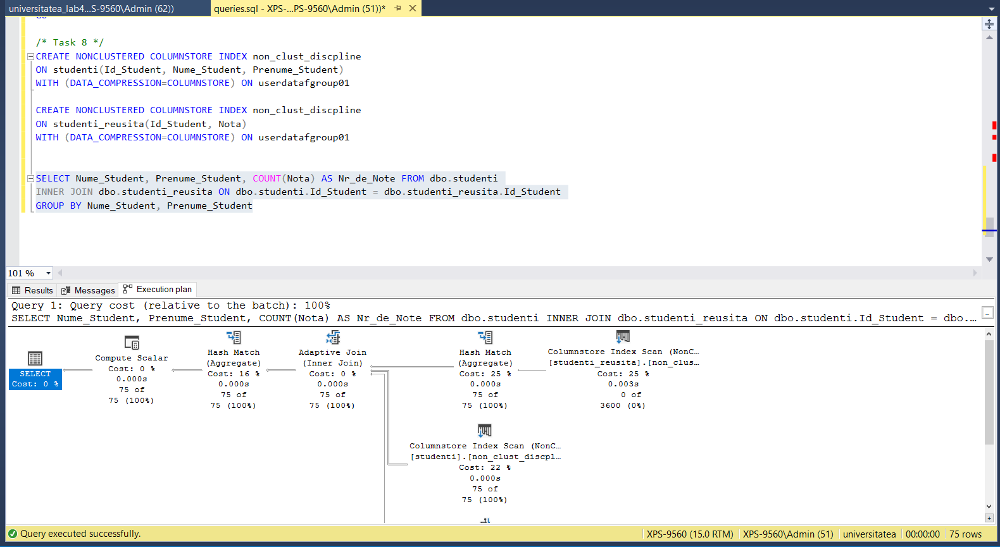

**Conclusion:**

In this work I had a possibility to work with CREATE and INSERT commands as well as practice different variations of them, such as INSERT INTO SELECT and SELECT INTO. Also, I’ve got a better understanding of indices and worked more with nested queries.